**School Name: Allenhouse Public School**

**Report on “Blogs (HTML5 and CSS3)”**

**By Sumit Yadav**

**Submitted to Mrs. Sonia Shah**

**I hereby declare this submission is my own work and that to the best of our knowledge and belief , it contains no material previously published or written by another person.**

**Name: Sumit Yadav**

**Class : 10th**

**Roll NO : 16**

*Firstly I would like thank god for giving me life and a chance to study.*

*Then, I would like to express my special thanks of gratitude to my teacher Mrs. Sonia as well as our principal Ma’am Gunjan Mehrotra who gave me the golden opportunity to do this wonderful project on my blog website, which also helped me in doing a lot of Research and i came to know about so many new things I am really thankful to them.*

*Secondly I would also like to thank my parents and friends who helped me a lot in finalizing this project within the limited time frame.*

Signature:

Name: Sumit Yadav

Roll No.:

Date:

**Introduction To My Project**

*This project aims to provide latest tech news. Related to each and every latest news about tech related things.*

*This project includes following pages:-*

1. *Home*
2. *Blogs*
3. *Query*
4. *About Me*

**Html Elements Used In This Project**

This project contains following HTML elements:-

* Paragraph <p>
* Images <img>
* Horizontal line <hr>
* Font (Color, Bold, Italics, Underline etc)
* Tables
* Forms
* Lists

|  |  |  |
| --- | --- | --- |
| S.No. | Title | Pg. No. |
|  |  |  |

***Index***

(Home Page)

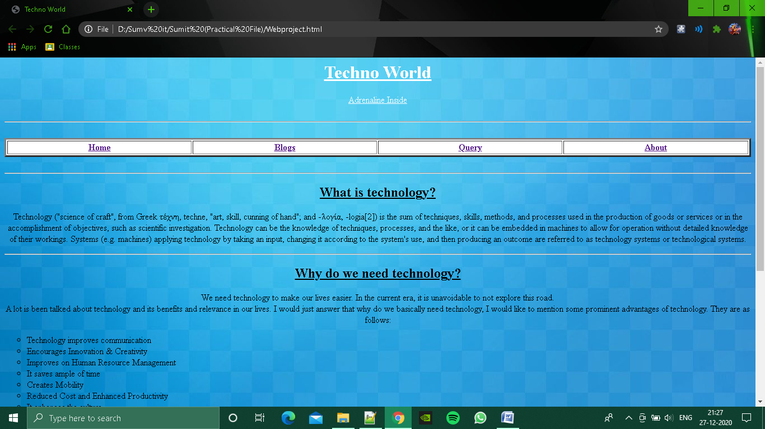

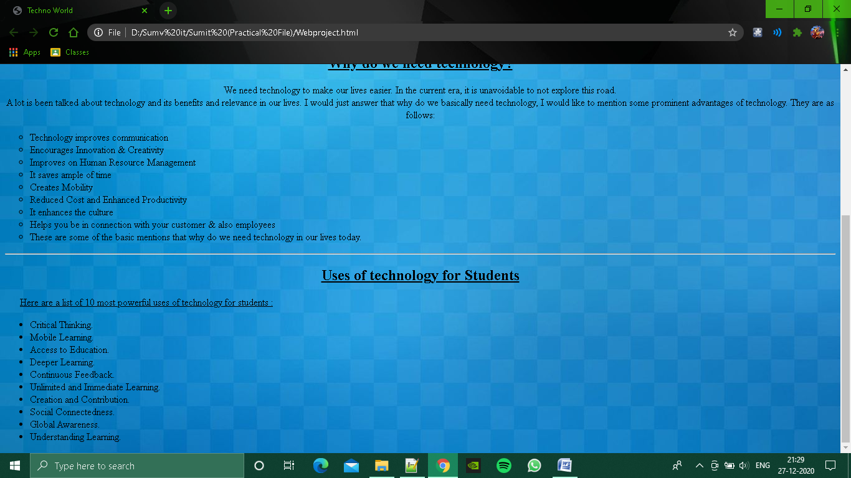

Code :

<html>

<head>

</head>

<title> Techno World </title>

<body background="Clean-Backgrounds-Download.jpg" height="100" width="100" >

<center>

<font color="white">

<h1><u><b> Techno World </u></b></h1>

<u> Adrenaline Inside </u>

</center>

</font>

<br>

<hr>

<br>

<center>

<table border="3" width="100%" bgcolor="white">

<tr>

<th width="20%" size="4"><a href="Webproject.html"> Home </a> </th>

<th width="20%" size="4"><a href="Blogs.html"> Blogs </a> </th>

<th width="20%" size="4"><a href="Login.html"> Query </a> </th>

<th width="20%" size="4"><a href="AboutMe.html"> About </a> </th>

</tr>

</table><br></center>

<hr>

<center>

<h2><u> What is technology? </h2> </u>

<p> Technology ("science of craft", from Greek τέχνη, techne, "art, skill, cunning of hand"; and -λογία, -logia[2]) is the sum of techniques, skills, methods, and processes used in the production of goods or services or in the accomplishment of objectives, such as scientific investigation. Technology can be the knowledge of techniques, processes, and the like, or it can be embedded in machines to allow for operation without detailed knowledge of their workings. Systems (e.g. machines) applying technology by taking an input, changing it according to the system's use, and then producing an outcome are referred to as technology systems or technological systems.</p>

<hr>

<h2><u> Why do we need technology? </h2></u>

<p> We need technology to make our lives easier.

In the current era, it is unavoidable to not explore this road.<br>

A lot is been talked about technology and its benefits and relevance in our lives. I would just answer that why do we basically need technology, I would like to mention some prominent advantages of technology. They are as follows:<br></center>

<ul type="circle" >

<li>Technology improves communication</li>

<li>Encourages Innovation & Creativity</li>

<li>Improves on Human Resource Management</li>

<li>It saves ample of time</li>

<li>Creates Mobility</li>

<li>Reduced Cost and Enhanced Productivity</li>

<li>It enhances the culture</li>

<li>Helps you be in connection with your customer & also employees</li>

<li>These are some of the basic mentions that why do we need technology in our lives today.</li>

</ul>

<hr>

<h2><center><u> Uses of technology for Students </h2></center></u>

<p>&nbsp; &nbsp; &nbsp; <u> Here are a list of 10 most powerful uses of technology for students : </u></p>

<ul>

<li>Critical Thinking.</li>

<li>Mobile Learning.</li>

<li>Access to Education.</li>

<li>Deeper Learning.</li>

<li>Continuous Feedback.</li>

<li>Unlimited and Immediate Learning.</li>

<li>Creation and Contribution.</li>

<li>Social Connectedness.</li>

<li>Global Awareness.</li>

<li>Understanding Learning.</li>

</ul>

</body>

</html>

(Blog Page)

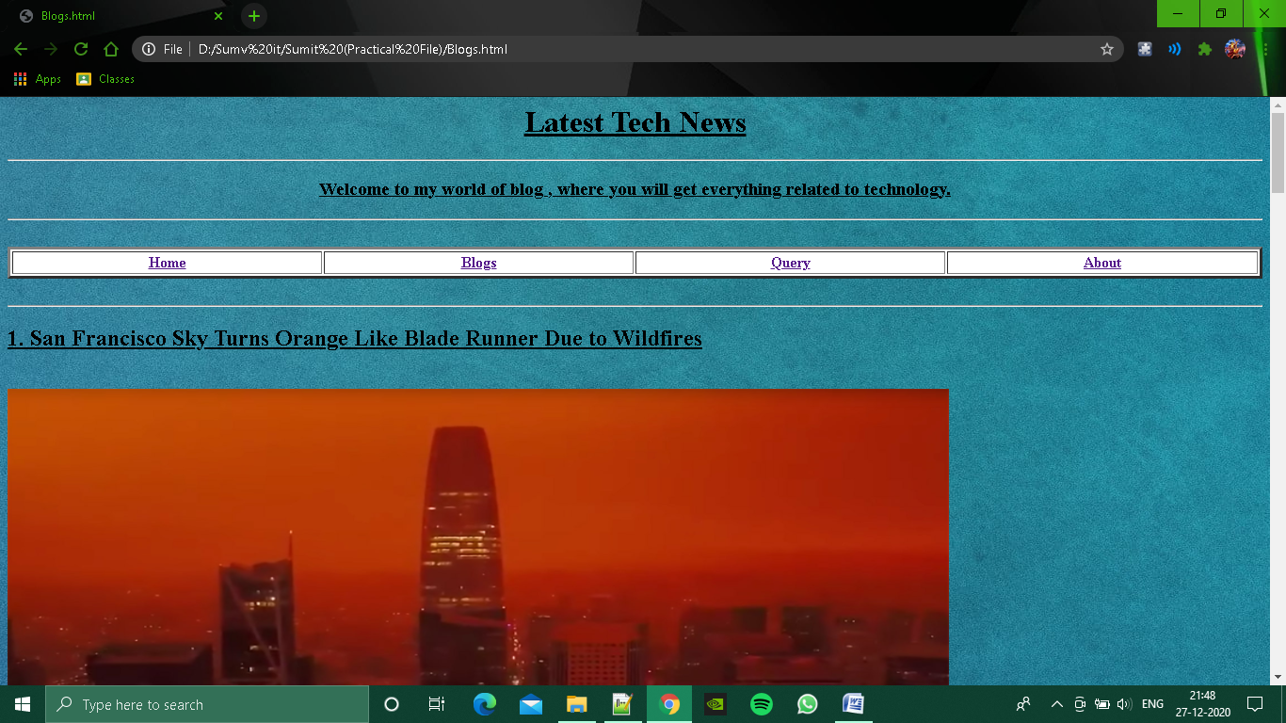

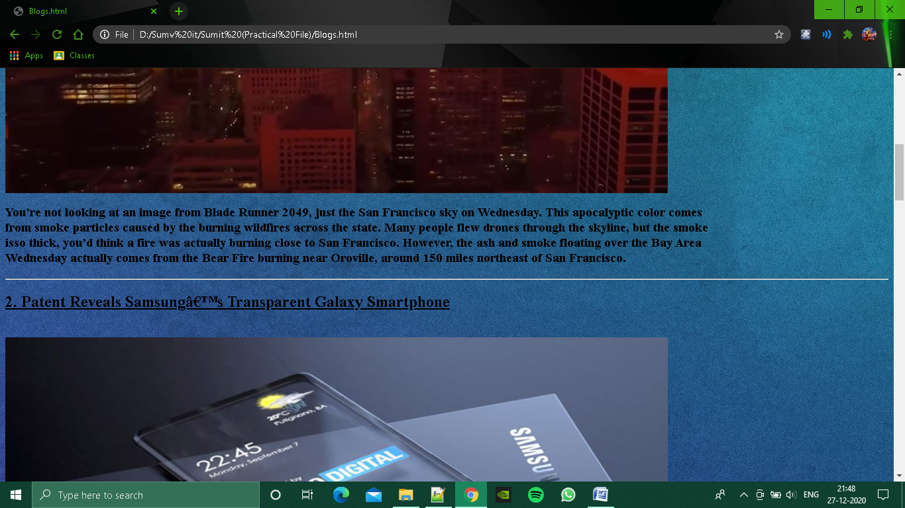

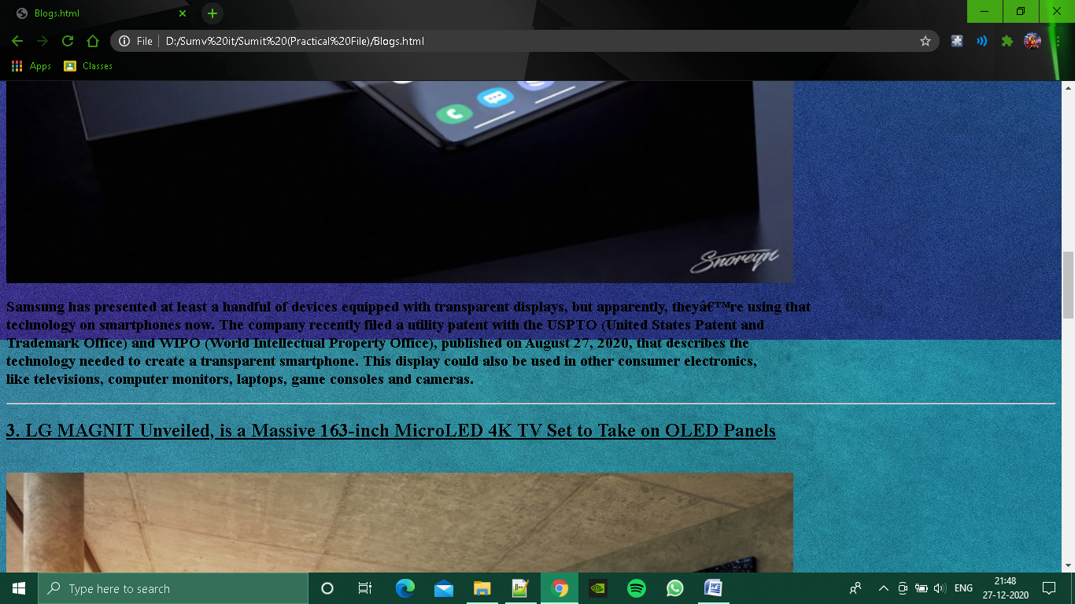

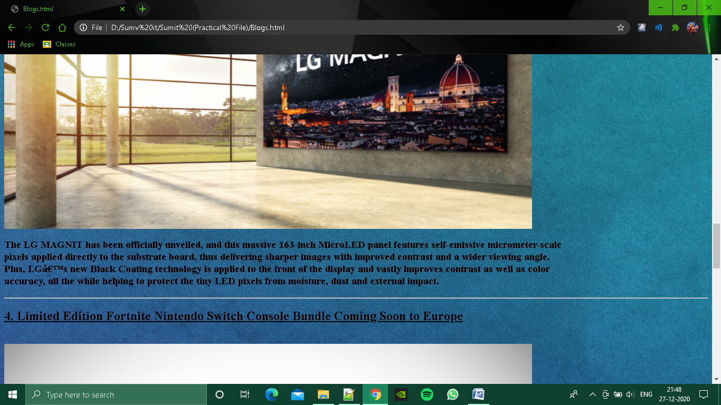

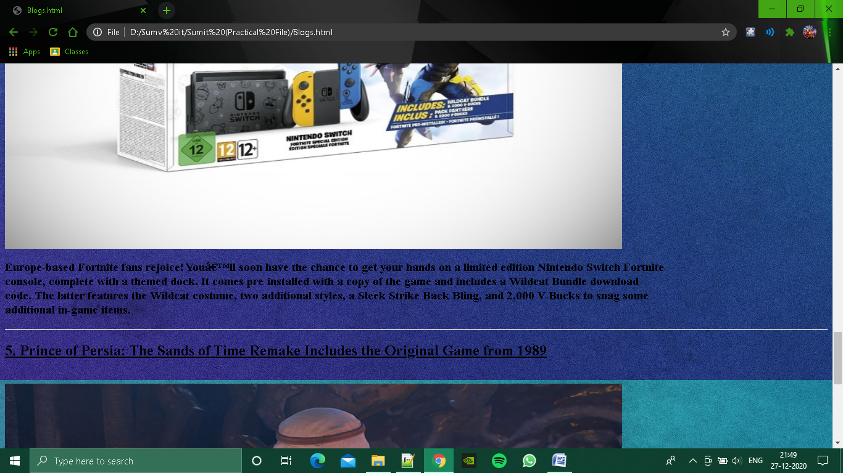

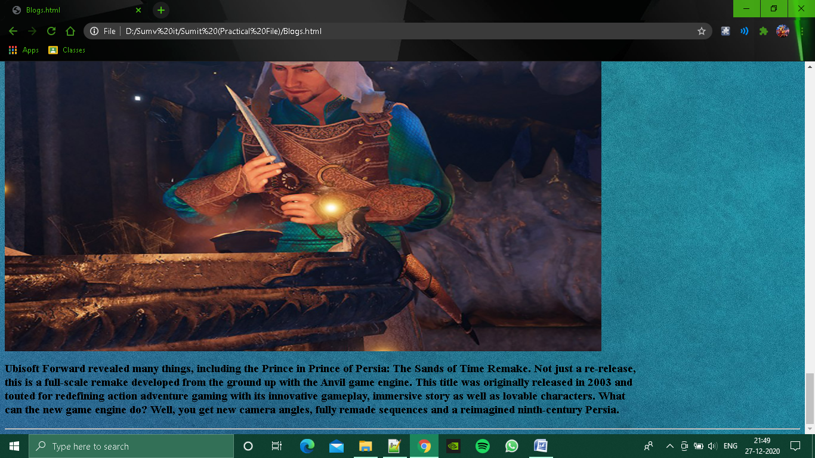

Code :

<html>

<body background="svjh.jpg">

<center>

<h1><b><u> Latest Tech News </u></b></h1></center>

<center>

<hr>

<h3><u> Welcome to my world of blog , where you will get everything related to technology.</h3></u>

<table border="3" width="100%" bgcolor="white" background="si.jpg">

<th width="20%" size="4"><a href="Webproject.html"> Home </a> </th>

<th width="20%" size="4"><a href="Blogs.html"> Blogs </a> </th>

<th width="20%" size="4"><a href="Login.html"> Query </a> </th>

<th width="20%" size="4"><a href="AboutMe.html"> About </a> </th>

</tr>

<hr>

<br>

</table><br></center>

<hr>

<h2><u> 1. San Francisco Sky Turns Orange Like Blade Runner Due to Wildfires </u></h2><br>

<img src="https://media.techeblog.com/images/san-francisco-blade-runner-2049-orange-sky.jpg" height="600" width="1000" ><br>

<p><h3><header>

You&#8217;re not looking at an image from Blade Runner 2049, just the San Francisco sky on Wednesday. This apocalyptic color comes<br> from smoke particles caused by the burning wildfires across the state. Many people flew drones through the skyline, but the smoke<br>isso thick, you&#8217;d think a fire was actually burning close to San Francisco. However, the ash and smoke floating over the Bay Area <br> Wednesday actually comes from the Bear Fire burning near Oroville, around 150 miles northeast of San Francisco.

</h3>

<hr>

<h2><u> 2. Patent Reveals Samsung’s Transparent Galaxy Smartphone </u></h2><br>

<img src="https://media.techeblog.com/images/samsung-transparent-galaxy-smartphone.jpg" height="600" width="1000" ><br>

<p><h3><header>

Samsung has presented at least a handful of devices equipped with transparent displays, but apparently, they’re using that <br> technology on smartphones now. The company recently filed a utility patent with the USPTO (United States Patent and <br> Trademark Office) and WIPO (World Intellectual Property Office), published on August 27, 2020, that describes the <br> technology needed to create a transparent smartphone. This display could also be used in other consumer electronics,<br> like televisions, computer monitors, laptops, game consoles and cameras.

</h3>

<hr>

<h2> <u> 3. LG MAGNIT Unveiled, is a Massive 163-inch MicroLED 4K TV Set to Take on OLED Panels </u> </h2> <br>

<img src="https://media.techeblog.com/images/lg-magnit-163-inch-microled-oled.jpg" height="600" width="1000" ><br>

<p><h3><header>

The LG MAGNIT has been officially unveiled, and this massive 163-inch MicroLED panel features self-emissive micrometer-scale <br> pixels applied directly to the substrate board, thus delivering sharper images with improved contrast and a wider viewing angle. <br> Plus, LG’s new Black Coating technology is applied to the front of the display and vastly improves contrast as well as color <br> accuracy, all the while helping to protect the tiny LED pixels from moisture, dust and external impact.

</h3>

<hr>

<h2><u> 4. Limited Edition Fortnite Nintendo Switch Console Bundle Coming Soon to Europe </u></h2><br>

<img src="https://media.techeblog.com/images/limited-edition-fortnite-nintendo-switch-bundle-console.jpg" height="600" width="1000" ><br>

<p><h3><header>

Europe-based Fortnite fans rejoice! You’ll soon have the chance to get your hands on a limited edition Nintendo Switch Fortnite <br> console, complete with a themed dock. It comes pre-installed with a copy of the game and includes a Wildcat Bundle download <br> code. The latter features the Wildcat costume, two additional styles, a Sleek Strike Back Bling, and 2,000 V-Bucks to snag some <br> additional in-game items.

</h3>

<hr>

<h2><u> 5. Prince of Persia: The Sands of Time Remake Includes the Original Game from 1989 </u></h2><br>

<img src="https://media.techeblog.com/images/prince-of-persia-the-sands-of-time-remake.jpg" height="600" width="1000" ><br>

<p><h3><header>

Ubisoft Forward revealed many things, including the Prince in Prince of Persia: The Sands of Time Remake. Not just a re-release, <br> this is a full-scale remake developed from the ground up with the Anvil game engine. This title was originally released in 2003 and <br> touted for redefining action adventure gaming with its innovative gameplay, immersive story as well as lovable characters. What <br> can the new game engine do? Well, you get new camera angles, fully remade sequences and a reimagined ninth-century Persia.

</h3>

<hr>

</body>

</html>

Query :

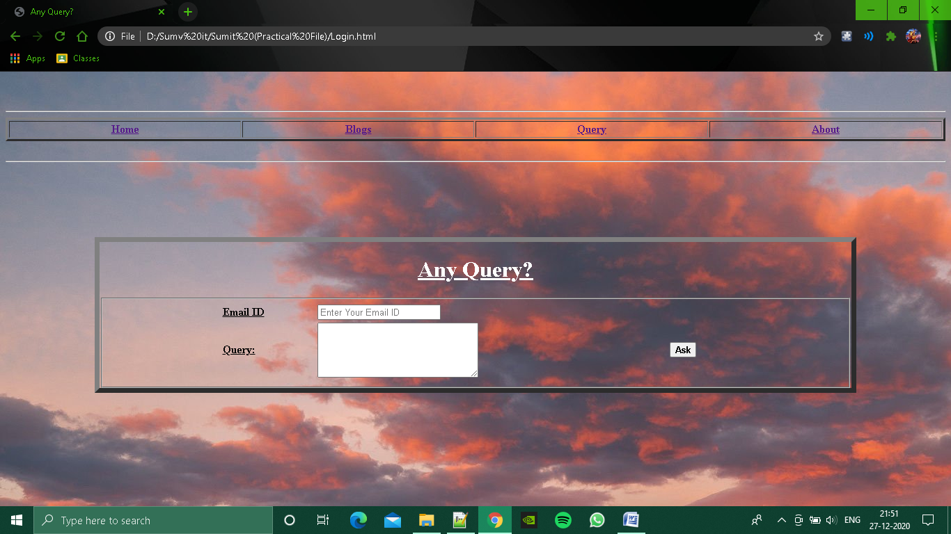

Code :

<html>

<head></head>

<title> Any Query? </title>

<body background="https://images6.alphacoders.com/697/thumb-1920-697730.jpg">

<br>

<br>

<hr>

<center>

<table border="3" width="100%" background="si.jpg">

<tr>

<th width="20%" size="4"><a href="Webproject.html"> Home </a> </th>

<th width="20%" size="4"><a href="Blogs.html"> Blogs </a> </th>

<th width="20%" size="4"><a href="Login.html"> Query </a> </th>

<th width="20%" size="4"><a href="AboutMe.html"> About </a> </th>

</tr>

</table><br></center>

<hr>

<br>

<br>

<br>

<br>

<br>

<center>

<form style="width:80% ;border-style:outset; border-color:grey; border-width:7px" >

<center><h1><font color="white"><u> Any Query? </u></h1></center></font>

<fieldset>

<center>

<table width="70%">

<tr>

<td><u><b> Email ID </b></u></td>

<td><input type="Text" placeholder="Enter Your Email ID"/> </td>

</tr>

<tr>

<td><u><b> Query: </b></u></td>

<td><Textarea rows="5" cols="30"> </textarea> </td>

<td> <button type="Submit" input type="Submit" ><b> Ask </b></button></td>

</tr>

</table>

</center>

</fieldset>

</form>

</body>

</html>

About :

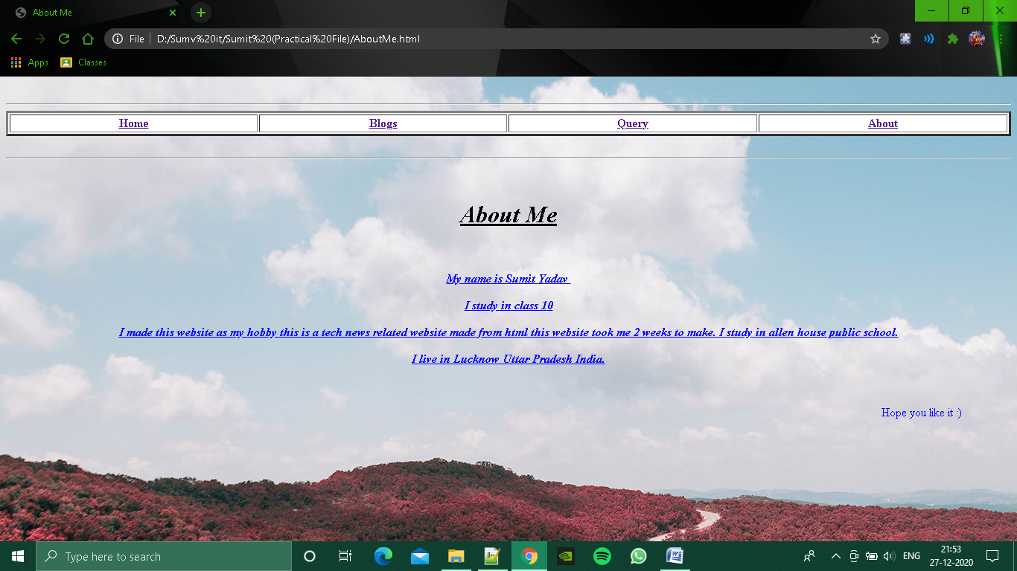

Code :

<html>

<head></head>

<title> About Me</title>

<body background="img(20).jpg" >

<center>

<font color="white">

<br>

<hr>

<center>

<table border="3" width="100%" bgcolor="white">

<tr>

<th width="20%" size="4"><a href="Webproject.html"> Home </a> </th>

<th width="20%" size="4"><a href="Blogs.html"> Blogs </a> </th>

<th width="20%" size="4"><a href="Login.html"> Query </a> </th>

<th width="20%" size="4"><a href="AboutMe.html"> About </a> </th>

</tr>

</table><br></center>

<hr>

<P>

<br>

<font color="black">

<h1><i><b><u> About Me </u></h1><br></i></b>

<p style="text-align: center;"><span style="color: blue;"><u><b><i></i></b></u></span></p><p style="text-align: center;"><span style="color: blue;"><u><b><i>My name is Sumit Yadav&nbsp;</i></b></u></span></p><p style="text-align: center;"><span style="color: blue;"><u><b><i>I study in class 10</i></b></u></span></p><p style="text-align: center;"><span style="color: blue;"><u><b><i>I made this website as my hobby this is a tech news related website made from html this website took me 2 weeks to make. I study in allen house public school.</i></b></u></span></p><p style="text-align: center;"><i style="color: blue; font-weight: bold; text-decoration-line: underline;">I live in Lucknow Uttar Pradesh India. </i><span style="color: blue;"><b><i><u></u></i></b></span></p><p style="text-align: center;"><p style="text-align: center;"><p &nbsp; &nbsp; &nbsp; &nbsp; &nbsp; &nbsp; &nbsp; &nbsp; &nbsp; &nbsp; &nbsp; &nbsp; &nbsp; &nbsp; &nbsp; &nbsp; &nbsp; &nbsp; &nbsp; &nbsp;Gmail-&nbsp;</p><p style="text-align: left;"><br /></p><p style="text-align: center;"><span style="color: blue;">

<marquee> Hope you like it :) </marquee>

</body>

</html>